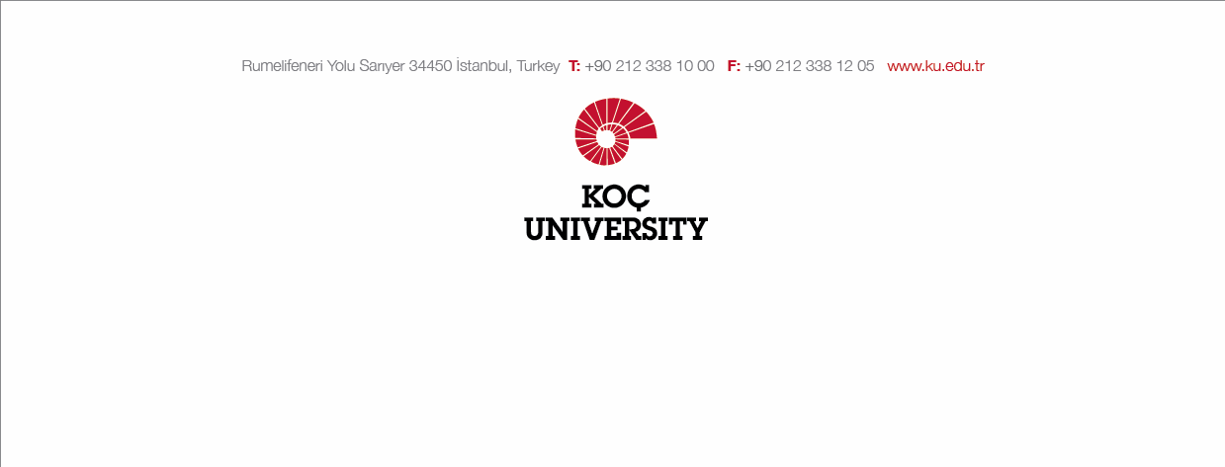
Date:

TO KOC UNIVERSITY OFFICE OF INTERNATIONAL PROGRAMS,

I’m a undergradute/graduate student at the department of …………………………….… at Koc University. I was selected to participate in an exchange program at
……………………….university in the 202…/202… academic year with the Erasmus / Global Exchange / Summer School program.
I would like to cancel my exchange program due to the matter of ……………………...
I am aware that my right to attend this program cannot be transferred to the next academic year.

Respectfully submitted to your attention.

Name:
Signature:

